P.THANGA ANU PRIYA

1911031

1.Create a Bucket in IBM object storage.

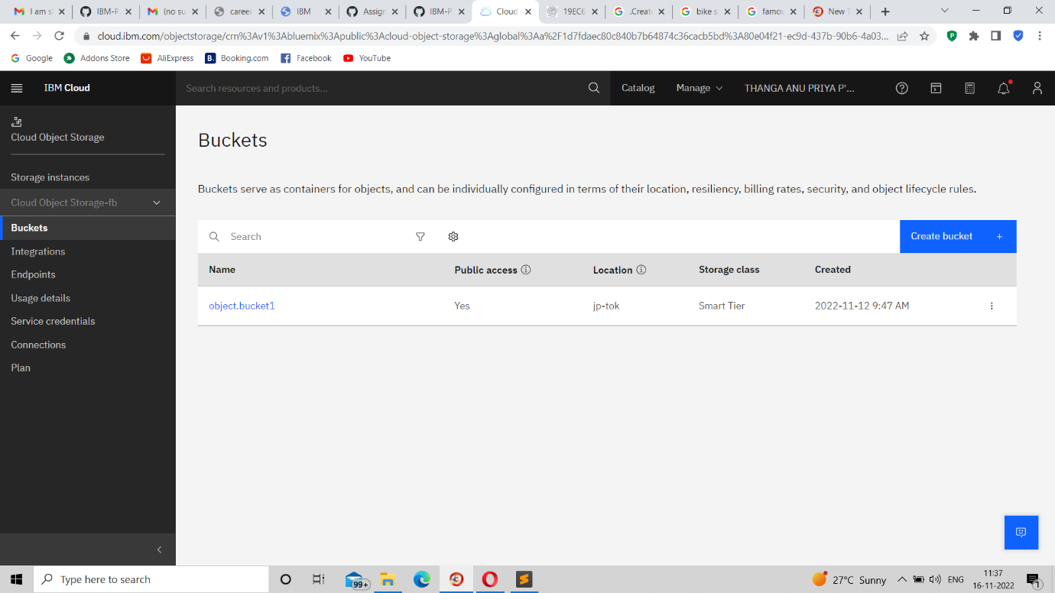

2.Upload an 5 images to ibm object storage and make it public. write html code to displaying all the 5 images.

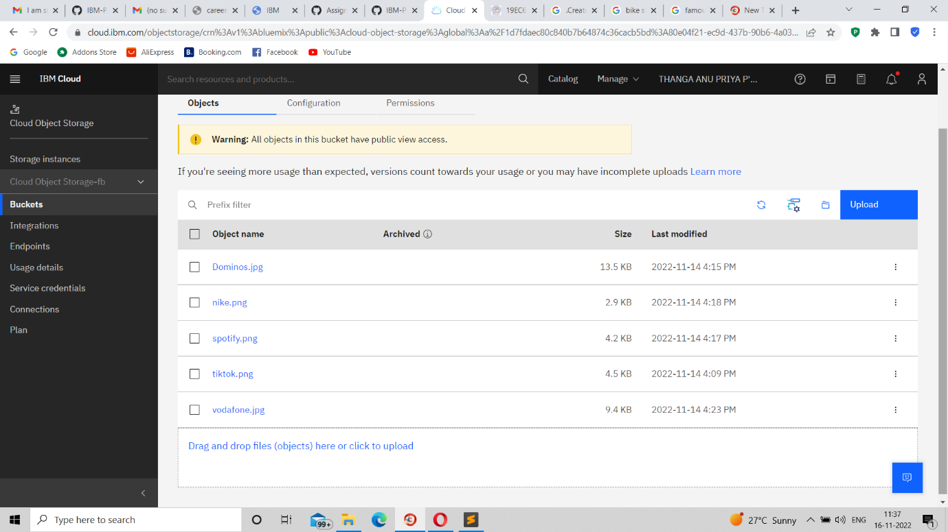

|  |
| --- |
| 4.Design a chatbot using IBM Watson assistant for hospital. Ex: User comes with query to know the branches for that hospital in your city. Submit the web URL of that chat bot as a assignment. |
|  |
| <https://web-chat.global.assistant.watson.appdomain.cloud/preview.html?backgroundImageURL=https%3A%2F%2Fau-syd.assistant.watson.cloud.ibm.com%2Fpublic%2Fimages%2Fupx-1d3499d4-6983-4281-968b-32f3f15987b8%3A%3A968c479f-800e-40ed-8e28-ca9a896bc584&integrationID=d653fb14-9fd4-4c1d-8f73-f8625c35132f&region=au-syd&serviceInstanceID=1d3499d4-6983-4281-968b-32f3f15987b8> |
|  |  |